The Hidden Army 2018
Abstract Submission Form

Please complete this form and submit as stated below:
Surname: | First Name: |  | Title (e.g. Dr, Ms, Mr):
Position: | Year of Study if applicable:
Email: |  | Telephone:
Institution and Department:
Authors:
Abstract Title:

Abstract:
Rationale & Hypothesis:
Objectives:

Methodology:

Findings:
Would you like your abstract to be considered for:
Oral presentation only
Oral & poster presentation

Abstract deadline is 22nd April 2016. The abstract word limit is 500 words.
Please email the completed form to: floreyinstitute@sheffield.ac.uk.
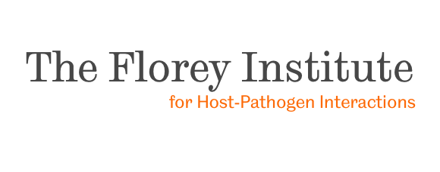
Following the deadline you will receive an email acknowledging receipt of your abstract

